Basic Certification –

Handshake Profile –

BYUI Connect Profile –

LinkedIn Profile –

VMOCK Resume Score –

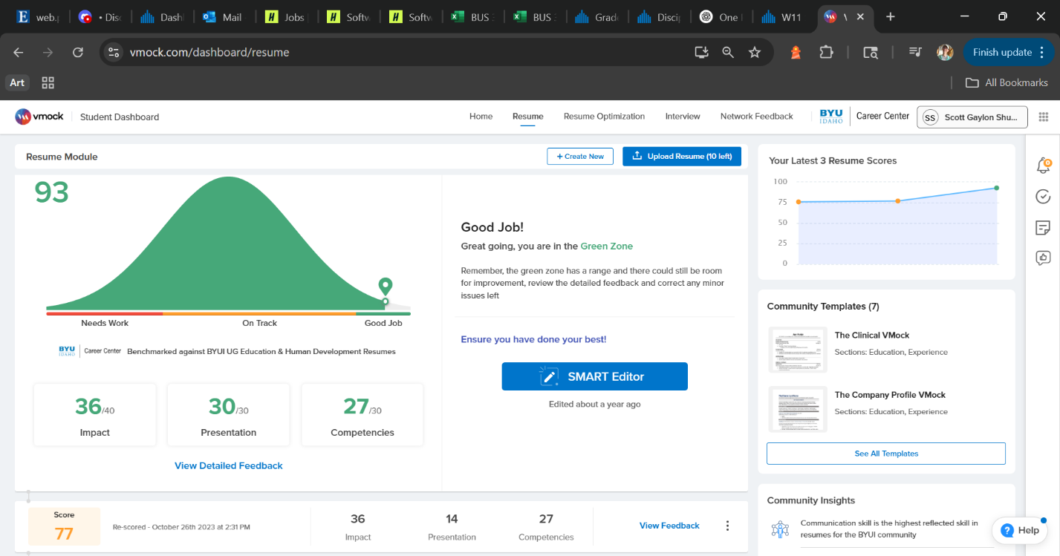

Informational Interviews –

1. [Informational Interview 1](file:///C:\Users\Shumw\OneDrive\Desktop\Files\BYU-I\Professional%20Readiness\Informational_Interview_1.docx)
2. [Informational Interview 2](file:///C:\Users\Shumw\OneDrive\Desktop\Files\BYU-I\Professional%20Readiness\InformationalInterview2.docx)
3. [Informational Interview 3](file:///C:\Users\Shumw\OneDrive\Desktop\Files\BYU-I\Professional%20Readiness\InformationalInterview3.docx)
4. [Informational Interview 4](file:///C:\Users\Shumw\OneDrive\Desktop\Files\BYU-I\Professional%20Readiness\InformationalInterview4.docx)
5. [Informational Interview 5](file:///C:\Users\Shumw\OneDrive\Desktop\Files\BYU-I\Professional%20Readiness\InformationalInterview5.docx)

LinkedIn Connections –

Silver Certification –

